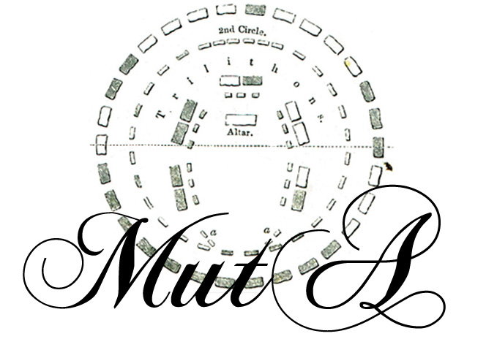

To print and to return to :)
Gabriel MARTIN
c/o MUTA, Maison Gure Amexa, R.D 712, 64990 MOUGUERRE, FRANCE

DATE :

MY CONTACTS
Name: _______________________________________ Firstname : _________________________________
Adress : _______________________________________ __________________________________________
Code postal : ___________________ City : ________________________Country :_____________________
Email : _______________________________ (if you want to receive news about us)
Shipping adress (if different)
Name : _______________________________________ Firstname : _________________________________
Adress : _______________________________________ __________________________________________
Code postal : ___________________ City : ________________________Country :_____________________

 |  |  | MY ORDER
Produit |  | Désignation |  | Color | Size | Quantity | Price per article | Total
CD « Muta » |  | CD 6 songs (duration : 28 min) |  |  |  |  | 5 € | €
T-SHIRT |  | Short sleeves (195g/m²) |  |  |  |  | 10 €
T-SHIRT Girlie |  | Girl version |  |  |  |  | 10 €
Shipping : |  | 3 euros /CD  4 euros /T-SHIRT |  |  |  | Order Total: |  | €
Colors and sizes available :
T-SHIRT / / Color : Black, Chocolate, Beige / Taille : S, M, L, XL
T-SHIRT Girlie / / Color : Black, Red, Green / Taille : M, L

(Cheque payable to : « Gabriel MARTIN »)

MUTA thanks you for your support

